EUROPEAN ELECTIONS 2019
VICTIM SUPPORT EUROPE MANIFESTO
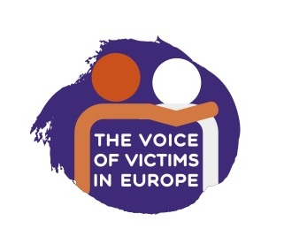
MAKE VICTIMS' RIGHTS A REALITY

For over 60 years the European Union has stood for social justice and fundamental rights. Those principles are increasingly under threat and we must work together to protect them.

Justice, inclusion and support for all are critical to victims of crime and form part of these fundamental values.
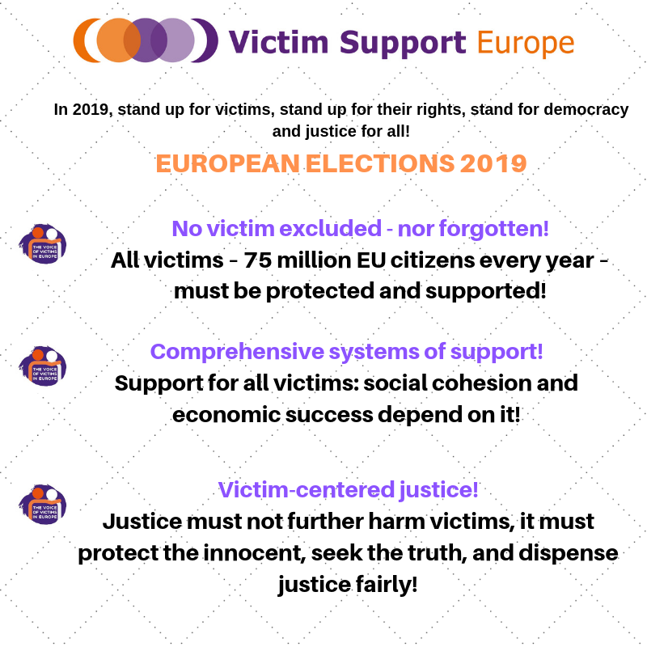

Victim Support Europe is committed to working with MEPs and to providing recommendations for victim-centered approaches to these upcoming challenges.
- No victim excluded - nor forgotten:
The EU can no longer afford to take piecemeal action on victims rights. We must pursue laws and policies which, whilst developing specialist rules for specific groups, benefit all victims of crime. This means acting on cross cutting issues such as access to support systems, compensation, legal aid, and training. It means that the victim’s perspective has to be mainstreamed into all the EU’s policies. It means that victims of crimes such as gender based violence, sexual abuse, human trafficking and terrorism need specific rights and services. It means that actions relating to specific groups such as people with disabilities, LGBTI+ community, religious or ethnic minorities, older people, children and women should always include a focus on crime and victimisation. It also means that the EU must take a leadership role on the global stage, promoting rights and services for all victims of crime, no matter where they are, no matter what the crime.
Whether discussing discrimination and equal treatment, the rights of children, the elderly, migrants, the LGBTI+ community or others, the impact of crime on them and appropriate responses must be considered. Legislation and policies on law enforcement, counter terrorism, migration, health, education and sustainability have to take into account the impact of crime, the effect on victims and how victims must be treated properly in those fields. Equally, the EU must act as global leader for victims’ rights supporting countries to improve the situation of victims across the world.
Key priorities affecting all victims: compensation, reporting, access to services, knowledge and information, new and emerging crimes, victims abroad, embassies, training and education of practitioners - change of culture is critical to success.
Victims’ rights should not be an after thought in legislative preparations but should be an integral part of discussions from the outset. Hearing the victims' voice directly is important. We want to have victims involved in our meetings and consultations not as an ornament, but as a real voice.
Victim Support Europe calls on the European Union to establish a clear long term vision for the development and implementation of victims’ rights. A strategic approach which ensures that victims issues are incorporated into wider social and law enforcement policies, should be coupled with complementary co-ordination mechanisms such as a victims intrergroup in the European Parliament and a victims’ coordinator in the European Commission.
The views and perceptions of the public and practitioners have to be transformed through education and awareness raising. Victimisation issues must be integrated into our education systems as a fundamental aspect of citizenship. The EU should follow the UN in supporting education for justice for children and adults in primary, secondary and tertiary education.

- Comprehensive systems of support:
Victims of crime are among the most vulnerable groups in need of government services. Yet, victim support services, if available, often vary in their quality and accessibility within countries and between countries. Service delivery failures can leave victims feeling helpless and abandoned, resulting in avoidable economic and social welfare costs.
Despite the requirement to establish national generic and specialist support services since 2015, in accordance with the Victims’ Rights Directive, many Member States still do not have such services in place, and where they do, services are usually not working well in practice. The EU must act to ensure all Member States establish national victim support services, that they operate properly and that the public and victims are informed of these services and have easy access to them.
In the next legislative period, the EU must continue to develop policies on the delivery of support services to ensure that victims have access to a full range of basic services including face to face support and national 116 006 helplines, and that minimum quality standards exist to ensure the welfare and safe of victims using those services.

- Victim-centered justice:
Our justice systems are consistently failing victims from the moment of reporting a crime, throughout investigation and proceedings and beyond to sentencing and probation. The process of seeking the truth should not be so harmful that victims do not come forward, that they drop out of the process or that it causes long term harm which in some cases leads to suicide.

The EU must act to ensure that victims are supported in seeking justice, are properly protected in the system and that victim sensitive practices are fully incorporated into basic training and lifelong learning of all those coming into contact with victims.

It is critical that over the next five years, existing European rights for victims in criminal proceedings are fully implemented and operational in practice. This means in particular that full and accessible information is provided, that victims are treated respectfully through proceedings, that their needs are properly assessed and that protection measures are genuinely provided.

The EU must also look to the future to identify innovative approaches to protecting victims in criminal proceedings and supporting their participation, to improve access to legal assistance and legal aid, to ensure better referral mechanisms between justice practitioners and support services, to ensure that victims policies are fully integrated and lie at the heart of alternatives to formal justice, and to improve state compensation and offender compensation systems.

How can the EU make a difference?

The European Union has a real power to change lives for the better, to improve the situation of all victims across the Member States and beyond.

Starting in 2019, the EU must show new leadership for victims. It must be coherent and comprehensive in its actions, with a long term vision for all victims which turns rights into reality, and which looks at future reform to develop new, innovative and cutting edge approaches to victim protection, support and justice.

To achieve these objectives, the EU must act to:

1) Enforce existing European laws in Member States. The EU must use supportive actions and infringement measures so that victims can truly rely on their rights.

2) Develop sufficient and coherent EU funding to support the implementation of rights and services. The widest possible range of EU funding programmes should incorporate victim priorities. Rules should be adapted to maximise access to frontline organisations, universities and state entities so they can work together to deliver activities which have the greatest impact on victims lives.

3) Support partnerships and support coordination across policies, European bodies, between States, NGOs, practitioners and victims themselves. Crime affects all aspects of a person’s life. It affects our communities and our economies. Actions to prevent crime and to help victims will only be fully affective where they are coordinated across all fields. The EU must develop actions which cut across traditional boundaries, which bring diverse actors together and support joint working on the ground. Coordinating bodies, networks and mechanisms should be developed to support specific victims policies.

4) Deepen and broaden knowledge through data collection and research. The victims’ field suffers from a significant lack of data and long term research. ‘We don’t have the data’ has become an excuse for inaction. The EU, in particular through Eurostat, must work with States to ensure data on victims and in the justice field is collected and analysed. Long term research projects bringing together practitioners and research institutes should be supported to understand the impact of crime, policies and new actions.

5) Directly support capacity building of individuals, organisations, and State authorities to better deliver high quality services and rights in a victim sensitive manner. Through its unique position, the EU bring together European and international best practices and directly support knowledge exchange, education and training.

