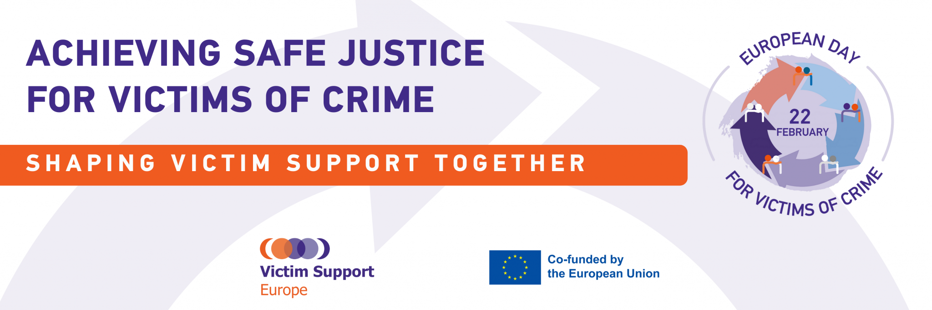
Victim Support Europe Announces #SafeJustice Campaign | Press Release

Brussels, 20 February 2023

A new social media campaign ‘Achieving Safe Justice for Victims of crime’ launched today by Victim Support Europe calls on the Member States, EU institutions, civil society and victims’ rights activists to continue to strive to improve the situation of victims.

In 1990 in Stockholm, Sweden, Victim Support Europe declared 22 February to be the European Day for Victims of Crime. The European Day offers the momentum to remember those who have suffered at the hands of criminals – many millions every year – children and adults, women and men, poor and wealthy, residents and visitors to the EU.

The Action Week for the European Day for Victims of Crime is an annual Victim Support Europe’s campaign that kicks off on the 20th of February and runs until 1 March. It is used as an organizing strategy by individuals and organizations around Europe to fight for progress, to support improvements in European and national laws, and above all to make sure those laws truly help all victims of crime, no matter the crime, no matter the victim.

In this 33rd edition, we will launch our new discussion paper ‘Achieving Safe Justice for Victims of crime’ that addresses the question on what makes the criminal justice system safe for victims and sets out recommendations on better path forward for criminal justice. What is presented in the paper articulates a vision that can form the core of a new, forward-looking model for safe justice systems in the EU.

Given that the European Commission has announced a possible proposal for a revision of the Victims' Rights Directive by March 2023, we believe it is key to seize the momentum to “go to the point” and put forward the solutions to the existing problems. This revision is indeed essential because it has the power to strengthen existing rights, establish clearer obligations for Member States and new rights for victims. Fundamentally, our responses to this should involve physical and mental health measures, criminal sanctions, economic cohesion, and safe justice, all elements brought together by our new policy and discussion papers.
This is why, together we welcome the commitment of the European Commission to update EU Victims’ laws and look forward to it urgently publishing a new Victims’ Rights Directive.
The #safejustice campaign kicks off with an in-person hybrid event ‘Achieving Safe Justice for Victims of Crime’ at The Press Club Brussels. The event will we live streamed on the Brussels Press Club TV: https://youtube.com/live/MJA0d4PiM90

The campaign is backed by victims-survivors, leading EU NGOs, victims’ rights advocates and activists across the EU who are sharing their voices and stories. The purpose of the online action is to bring to light experiences that can raise awareness about the existing challenges of a victim’s journey from crime to the outcome of criminal proceedings. With these stories we aim to address ways in which the justice system harms victims unnecessarily.

The campaign is running across major social media platforms: Twitter, Facebook, LinkedIn, Instagram. The Action Week invites netizens to create and share content as part of the bespoke hashtag #safejustice. It is a momentum of emotion, action and solidarity.

“My sister was killed by Daesh at the Brussels terrorist attacks in 2016. When you become victim of a terrorist attack, your life, your values, and assurances get completely shaken up. Providing an efficient support is very complex. Justice and truth are key pillars for many victims to rebuild themselves. Yet the justice system’s approach is often incomprehensible for the victims as the priorities differ. Due to this, the risk that victims harmed by crime feel unheard, misunderstood and revictimised is real. Encouragingly, it seems an increasing number of people are willing to step up and meet the challenges. The system does not lack examples of innovation and success, but these need to become the norm. This is why we must all be involved”, said Philippe Vansteenkiste, chair of V-Europe.

Levent Altan, Executive Director of Victim Support Europe, remarked that: “… in 2021, a courageous lady gave a speech at VSE’s Annual Conference. Nina Fuchs spoke of how she had been raped while under the influence of a date rape drug, how awful her experience – reporting the crime to the police and seeking justice – was. So terrible, as she told the audience in no uncertain terms, that her experience of the criminal justice system was worse than the rape itself. This is a truly sad indictment of our justice systems, of our responses to victimisation”.

Check and share the campaign’s Joint Statement (to be published on February 22) that was signed by the leading EU NGOs and national civil society organisations who call on every person to stand as one for victims and to support the publication of the revised Victims’ Rights Directive to ensure that no victim is forgotten or remains voiceless.

For more information about the campaign and campaign content, please go to the campaign webpage: https://victim-support.eu/media-center/campaigns/achieving-safe-justice-for-victims-of-crime/
____

